# Sejda

## Definition

**# Source**: **Windows ScreenShots From Site -> https://www.sejda.com/ at [8/29/2025]**

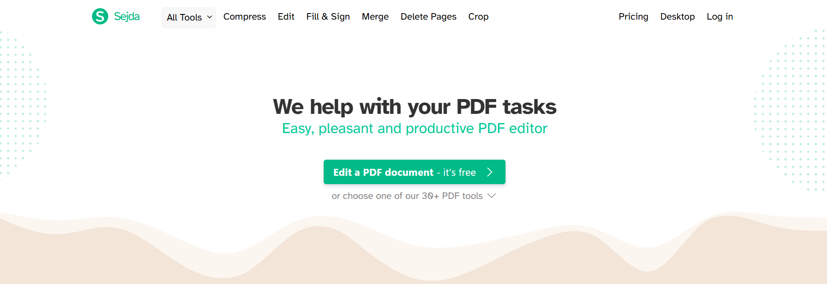

**# Source**: **Chatgpt (GPT-5-Standard) at [8/29/2025]**

**Sejda** is an **online PDF tool** (also available as a desktop app) that provides a wide range of features for working with PDF files.

✅ **It is mainly used for:**

* **Editing PDFs** → add or change text, images, shapes, and links directly in a PDF.
* **Annotating PDFs** → highlight, underline, add comments or sticky notes.
* **Filling & Signing** → complete PDF forms, add e-signatures, or create signable documents.
* **Merging PDFs** → combine several files into one document.
* **Splitting PDFs** → extract certain pages or split by bookmarks/size.
* **Compressing PDFs** → reduce file size without losing much quality.
* **Converting to/from PDF** → Word, Excel, PowerPoint, JPG, TXT, HTML, and more.
* **Organizing pages** → reorder, rotate, delete, duplicate, or extract specific pages.
* **Protecting & Unlocking PDFs** → add or remove passwords, set restrictions for printing or copying.
* **Watermarking** → add text or image watermarks for branding or protection.
* **Cropping & Resizing** → adjust page margins, crop content.
* **Header & Footer tools** → add page numbers, dates, or custom text.
* **Batch Processing** → apply actions (like compress or rename) to multiple files at once.
* **OCR (Optical Character Recognition)** → turn scanned PDFs/images into searchable, editable text.
* **Template & Forms** → create interactive forms with checkboxes, dropdowns, and fields.
* **Image to PDF & vice versa** → convert images into a PDF, or extract images from a PDF.
* **Online collaboration** → share documents securely for review/editing.

🔹 It is popular because it’s **easy to use, web-based (no install needed), and free for small tasks**, though it has limits unless you use the paid **Pro** version.